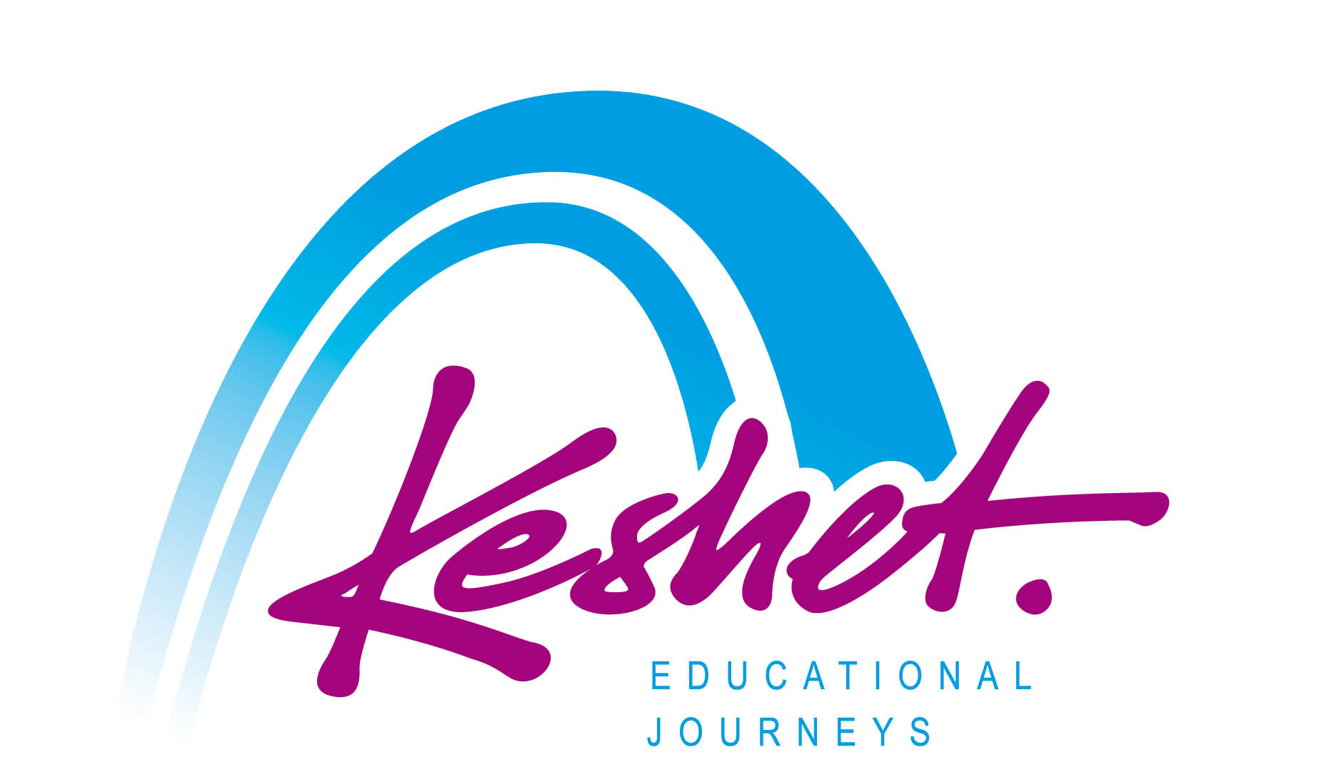
Litvak Heritage Tour
to Lithuania and Latvia
June 8-16, 2022
(Itinerary as of May 12, 2021 - Subject to Change)

Led by Rabbi Ari Cartun
with
Keshet Tour Educator Danny Ehrlich

The Germans and their allies destroyed the Jewish communities of Lithuania and Latvia, but their legacies are still alive and relevant in contemporary Jewish life. We will explore and trace the story of Litvak Jewry, to remember and learn about the past and to better understand the complex nature of our own contemporary Jewish identity, beliefs and practice.

_____________________________________________________________________________________________
Wednesday June 8
- Arrival in Vilna and check-in at our hotel (Check-in from 3 PM)
- Opening program: Introduction to Lithuania and Litvak Jewish Identity. There were 160,000 Jews in Lithuania before WWII making up 7% of the population. Over 100,000 lived in Vilna where Jews made up 45% of the population.
- Dinner with members of the local Jewish community
Overnight: Radisson Blu Astorija Hotel, Vilnius
_____________________________________________________________________________________________
Thursday June 9
- Breakfast at the hotel
- Explore the Medieval streets of Vilna and learn how Vilna became known as the Jerusalem of Lithuania.
- Visit the Vilna Gaon State Museum Tolerance Center and Holocaust Exposition, The Ghetto Memorials and other sites that testify to the significant Jewish history in Vilna.
- Lunch on your own
- Meetings with Lithuanian leaders
- Dinner on your own
Overnight: Radisson Blu Astorija Hotel, Vilnius
_____________________________________________________________________________________________
Friday June 10
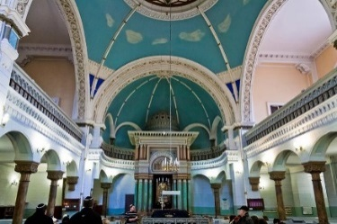
- Breakfast at the hotel
- Visit the Jewish Cemetery in Suderve which includes the tomb of the Rabbi Eliyahu ben Sholom Zalman (1720-1790) the towering Rabbinic figure known as the Vilna Gaon
- Stand in solemn memory at the Paneriai Forest Memorial (Ponar) where most of the Jews of Vilna were murdered by the Germans and their Lithuanian allies
- Return to central Vilnius for lunch on your own
- Meetings with local leaders
- Return to the hotel to prepare for Shabbat
- In the evening, we’ll head to the Choral Synagogue for Kabbalat Shabbat Services (Orthodox) followed by Shabbat Dinner with members of the local Jewish community
Overnight: Radisson Blu Astorija Hotel, Vilnius
Shabbat June 11
- Breakfast at the hotel
- Morning at leisure to attend Shabbat synagogue services or to explore the city on your own
- Lunch on your own (Kosher Shabbat lunch can be pre-ordered at additional cost)
- Afternoon walking tour through Vilnius Old Town including the Vilnius Cathedral Square.
- Study Session with Rabbi Cartun
- Dinner on your own
- Lithuanian Folklore Show
Overnight: Radisson Blu Astorija Hotel, Vilnius
_____________________________________________________________________________________________
Sunday June 12
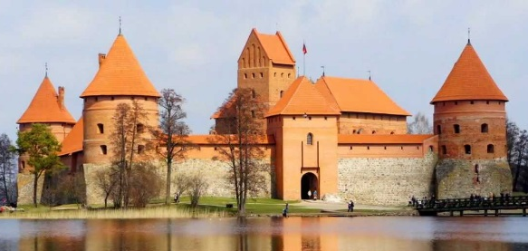
- Breakfast at the hotel
- Pack bus and depart Vilna to Trakai, once home to important (Rabbinic) Jewish and Karaite communities.
- Visit the Karaite Kenesa (Synagogue) and Museum and learn about the history of the Karaite and Jewish communities of Trakai. In 1897, the town population included 377 Karaites and 1,112 Rabbinite Jews, out of a general population of 3,240.
- Visit the Trakai Island Castle whose construction began in the 14th century.
- Packed Lunch
- Continue to Ziezmariai to see one of the very few wooden synagogues to survive the Shoah. In 1940 the 200 Jewish families of the town made up nearly 50 percent of the total population.
- Continue to Kaunas (Kovno). The 38,000 Jews of Kovno were 30% of the population before the Shoa
- Stand in solemn memory at the dramatic Ninth Fort Kaunas Holocaust Memorial where the Germans and their Lithuanian allies murdered over 15,000 Jews.
- Check-in at our hotel; evening and dinner on your own
Overnight: Radisson Blu Hotel, Kaunas
_____________________________________________________________________________________________
Monday June 13
- Breakfast at the hotel
- Pack bus and depart hotel
- Learn the inspiring story of Japanese diplomat Chiune Sugihara at the museum which was established in the home where he lived with his family. The museum tells the story of his efforts together with Dutch businessman and diplomat Jan Zwartendijk to save thousands of Jews.
- Visit the neo-baroque Kaunas Choral Synagogue built in 1872
- Lunch on your own
- Head to the Kovno Ghetto Memorial and see the site of the famed Slobodka Yeshivah
- Tour and tasting at the Stumbras Vodka & Spirits Museum
- Dinner and session with members of the Jewish community at the Jewish Community Center
- Return to the hotel for a session: The Jews of Siauliai. The 8,000 Jews were 25% of the population of Siauliai before the war
Overnight Radisson Blu Hotel, Kaunas ____________________________________________________________________________________________
Tuesday June 14
- Breakfast at the hotel
- Pack bus and depart hotel to Siauliai (Shavl)
- Visit sites of Jewish interest in Siaulia including: The Frenkel Mansion, originally home of industrialist Chaim Frenkel which later became a Jewish school and is now part of the city museum.
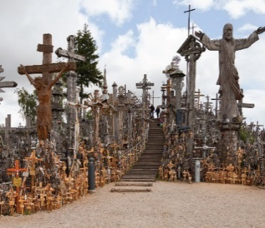
- See the Nazi era Ghettos and Holocaust memorials
- Packed Lunch
- Visit the dramatic Hill of Crosses, a major Christian pilgrimage site.
- Head north to Latvia. Prior to WWII, the approximately 95,000 Jews of Latvia were about 5% of the national population.
- Continue to Riga, capital of Latvia for check-in at our hotel.
- Dinner on own
Overnight: Grand Poet Semarah Hotel, Riga
____________________________________________________________________________________
Wednesday June 15
- Breakfast at the hotel
- Visit the memorial site of the Great Choral Synagogue destroyed by the Nazis in July 1941 and the Riga Ghetto and Latvian Holocaust Memorials. Prior to the Holocaust, Riga was home to almost 44,000 Jewish inhabitants making up 11% of the city population
- Tour the Jews in Latvia Museum at the Riga Jewish Community Center.
- Session with members of the Jewish community and learn about the challenges facing the community
- Lunch and shopping time on your own at the famous Riga Market.
- Stand in solemn memory in the Rumbula Forest where 25,000 Jews (mostly from the Riga Ghetto) were murdered by Germans and Latvians in November and December 1941.
- Return to Riga for a walking tour through the historic Art Nouveau district
- Tour and taste at the Black Balsam Distillery, Latvia’s signature herbal liquor developed in 1752 by Jewish pharmacist Abraham Krunze
- Panoramic cruise on the Daugava River
- Summary session and farewell dinner
Overnight: Grand Poet Semarah Hotel, Riga
____________________________________________________________________________________
Thursday June 16
- Breakfast at the hotel
- One group bus transfer to Riga Airport for flights to USA
- Listed activities and speakers are subject to confirmation.
- All breakfasts plus underlined meals are included in the package price.
- This itinerary is proprietary to Keshet and is intended for the promotion of and to inform those considering joining this Keshet trip. It is not to be transmitted to any other party without prior authorization from Keshet

Program prepared and operated by Keshet Educational Journeys
in cooperation with Jerulita Tours

Keshet Educational Journeys
PO Box 8540 Jerusalem 91084 Israel
Phone: 972-2-671-3518 | Fax: 972-2-671-3624

keshet@keshetisrael.co.il | www.keshetisrael.co.il

